

Course: CS 2005: Database Systems
Semester: Spring 2026
PROJECT REPORT:
VACCINATION MANAGEMENT SYSTEM (VMS)
24K-3041 Umair Ehtesham
24K-3099 Rumaesa
24K-3113 Ameerah

Introduction

- Motivation:
The manual handling of healthcare records often leads to data redundancy, loss of patient history, and inefficient inventory management. The motivation behind VMS is to provide a digitized, reliable, and transparent platform to manage the distribution and administration of vaccines.
- Tech Stack:
  - Backend: PHP (Server-side scripting for logic and database interaction).
  - Database: MySQL (Relational database for structured data storage).
  - Frontend: HTML5, CSS3 (Bootstrap 5 for a responsive layout), and JavaScript/jQuery.
- Objectives Achieved:
  - Developed a Role-Based Access Control (RBAC) system for Admins and Staff.
  - Implemented real-time inventory tracking and low-stock notification systems.
  - Created an automated appointment scheduling module with validation triggers.
  - Simplified the recording process for vaccine doses administered to citizens.
- Limitations:
  - The system currently lacks integrated SMS/Email gateways for automated notifications.
  - Offline data synchronization is not supported; a continuous internet connection is required.

Entity Relationship Diagram (ERD)

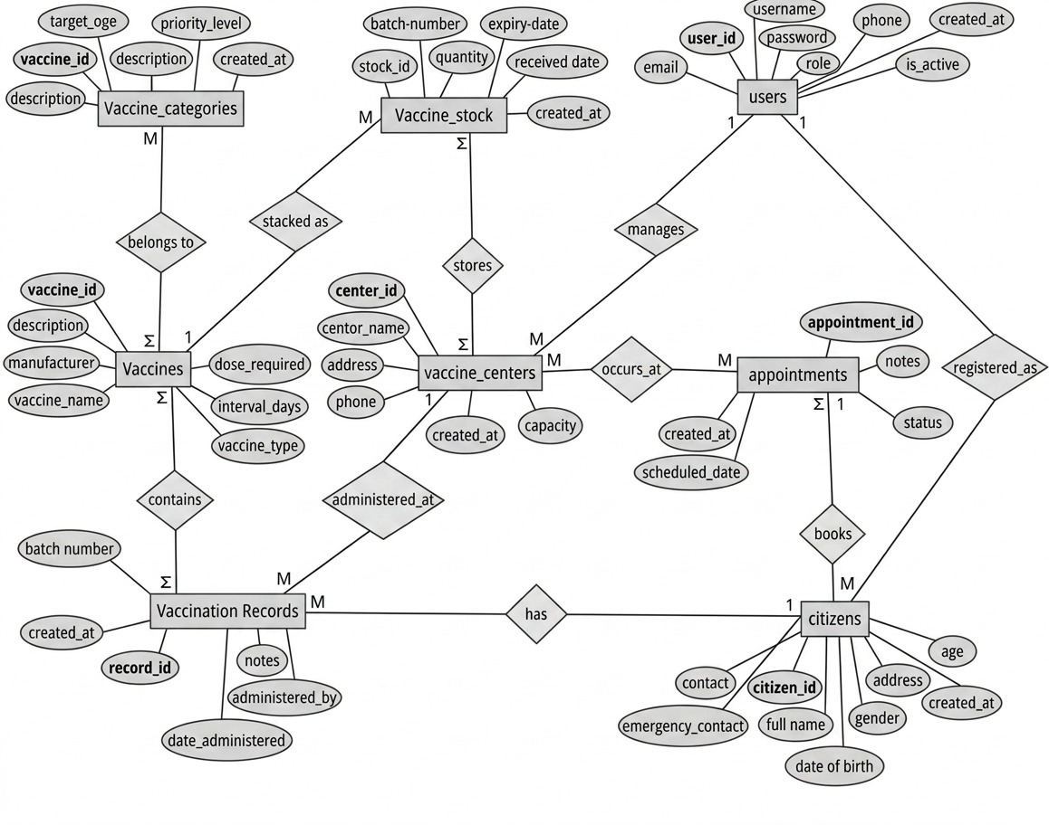

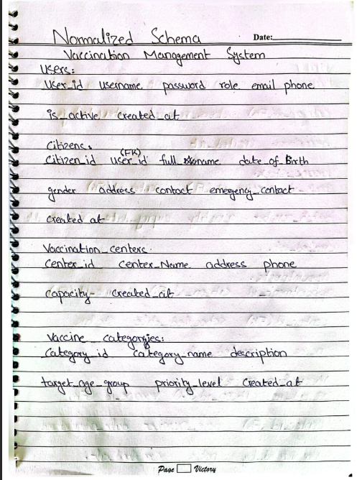
Normalized Schema

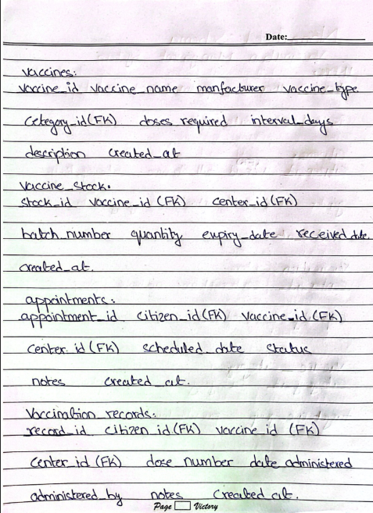

Features and Screenshots
- Admin Dashboard with statistics and vaccine reports.
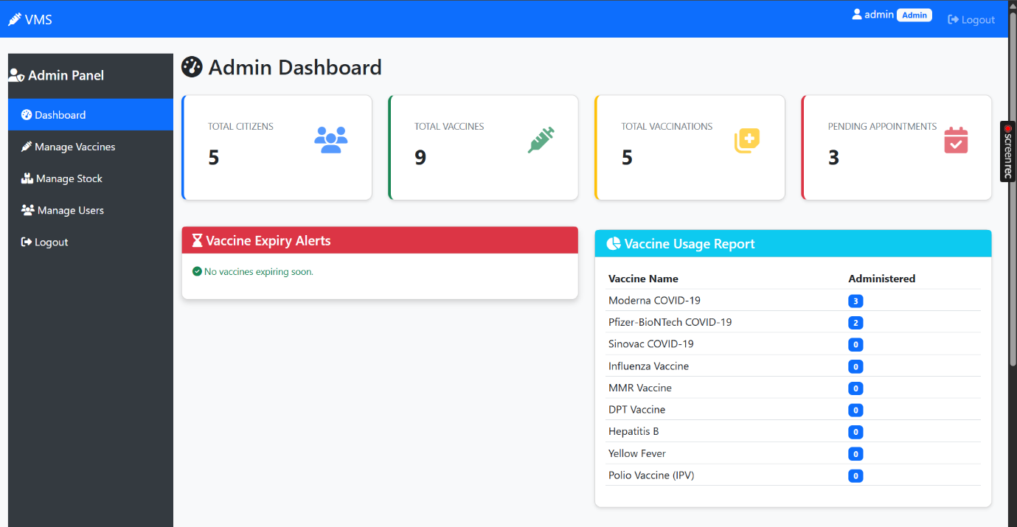
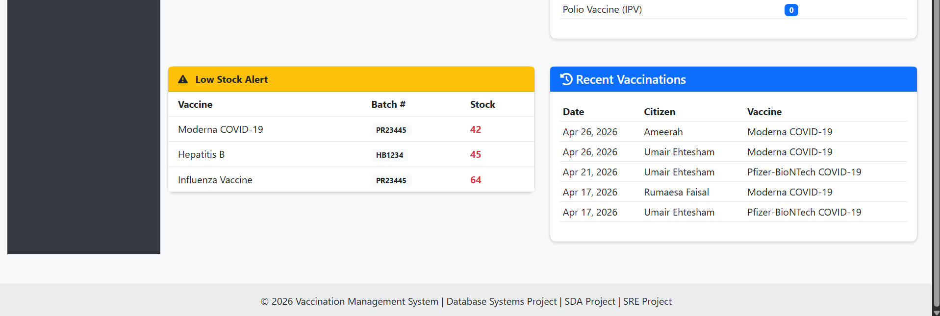

- Manage Vaccine by admin
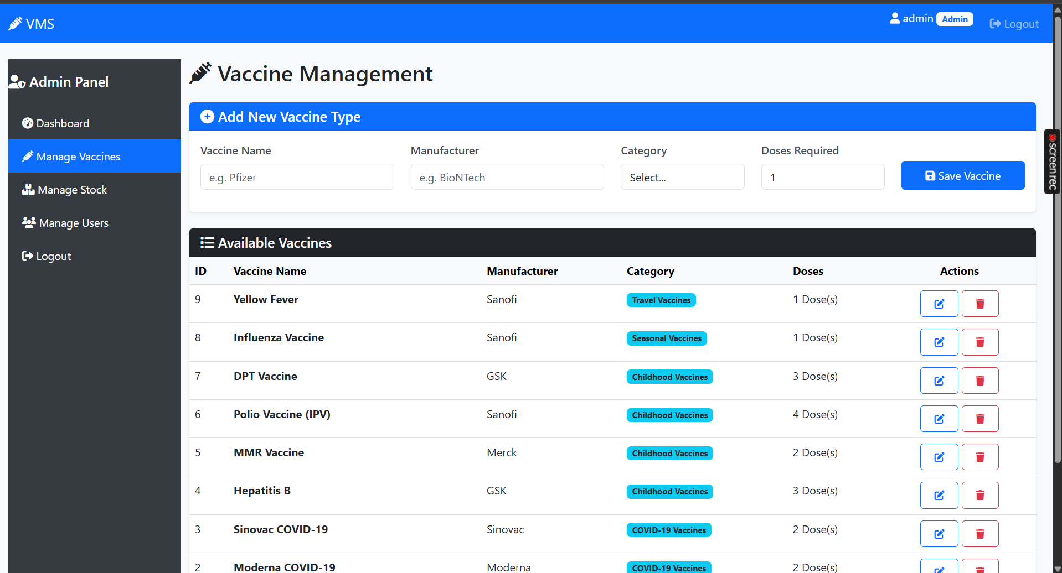

- Manage stock by admin
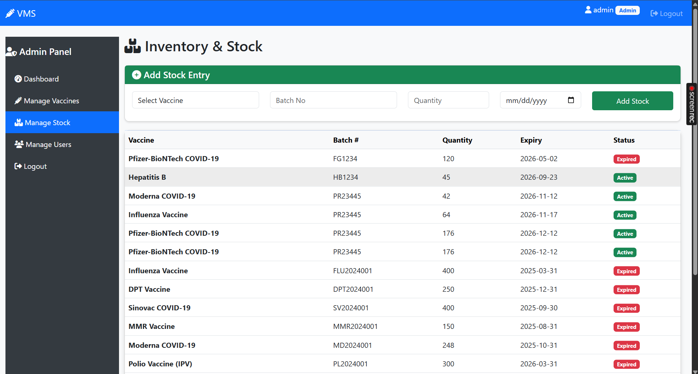

- Manage user by admin
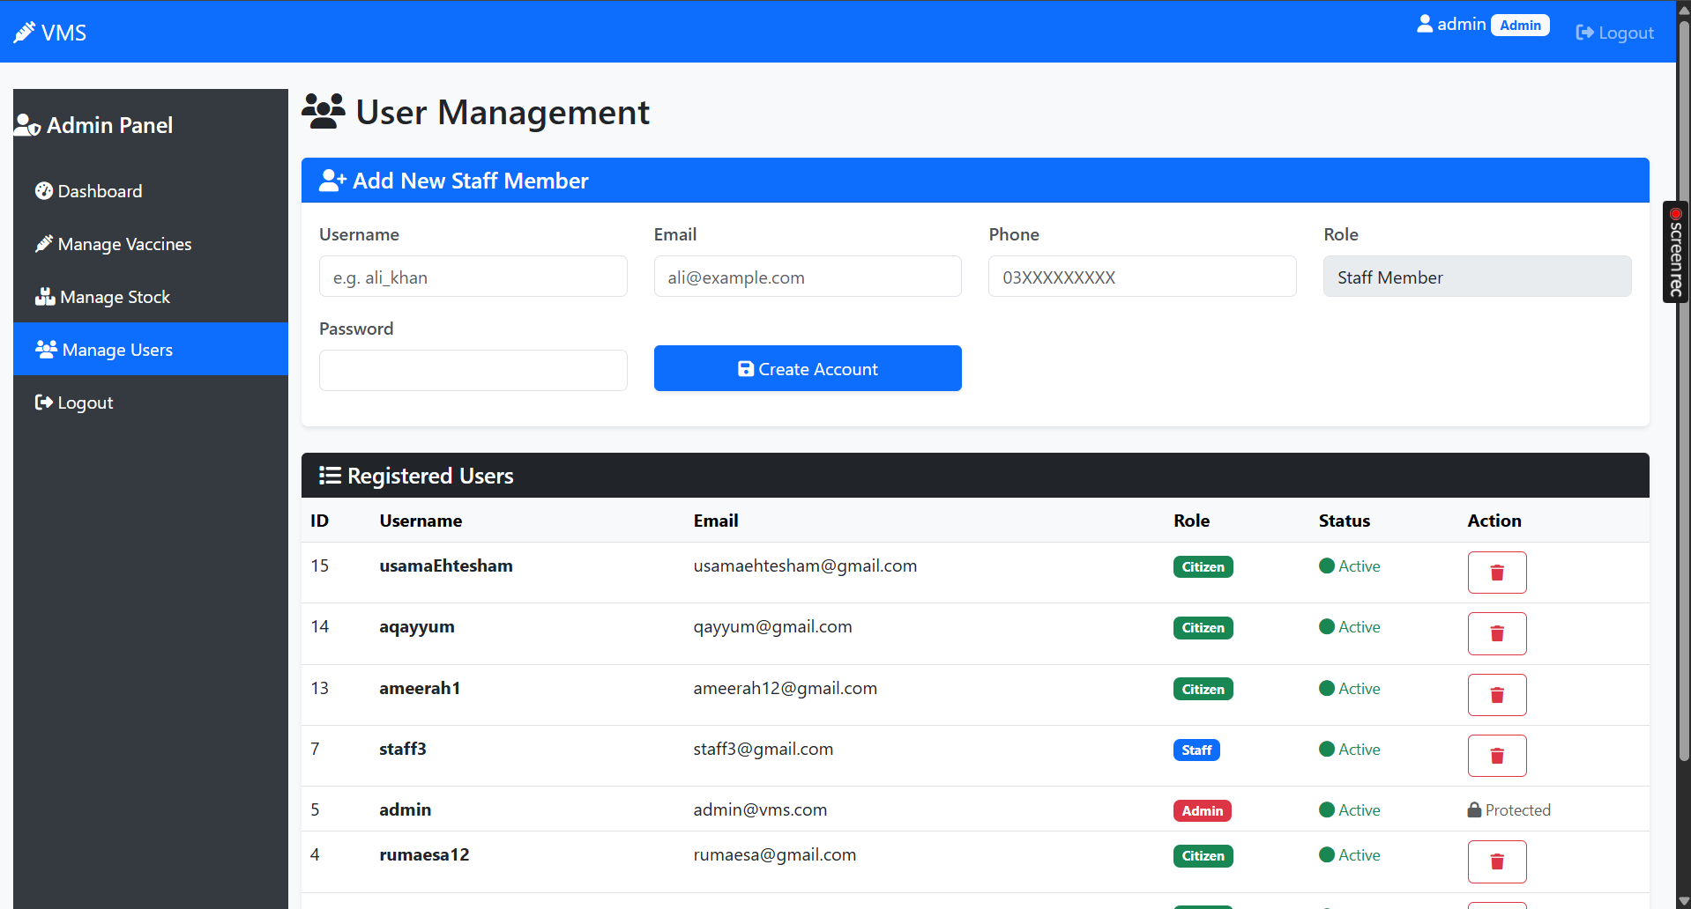

- Staff dashboard with stats
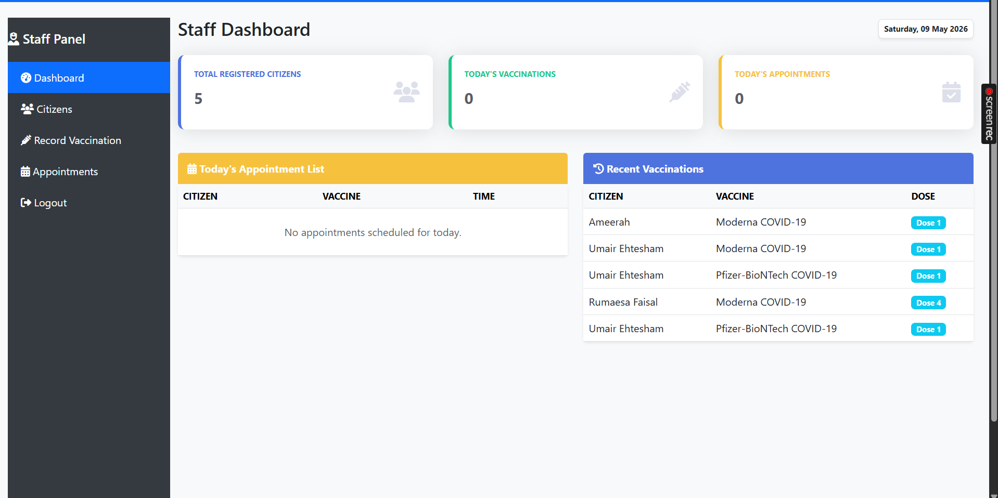

- Citizen Management by staff
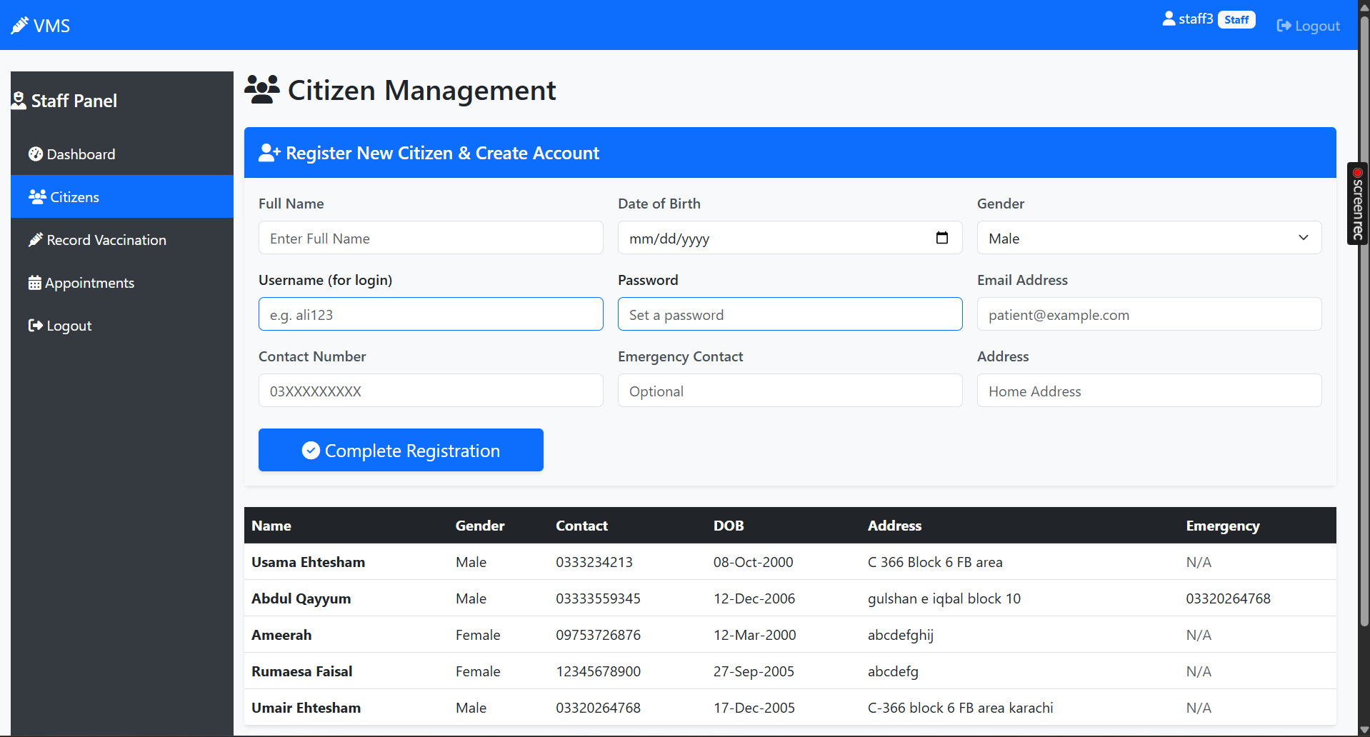

- Vaccination record by staff
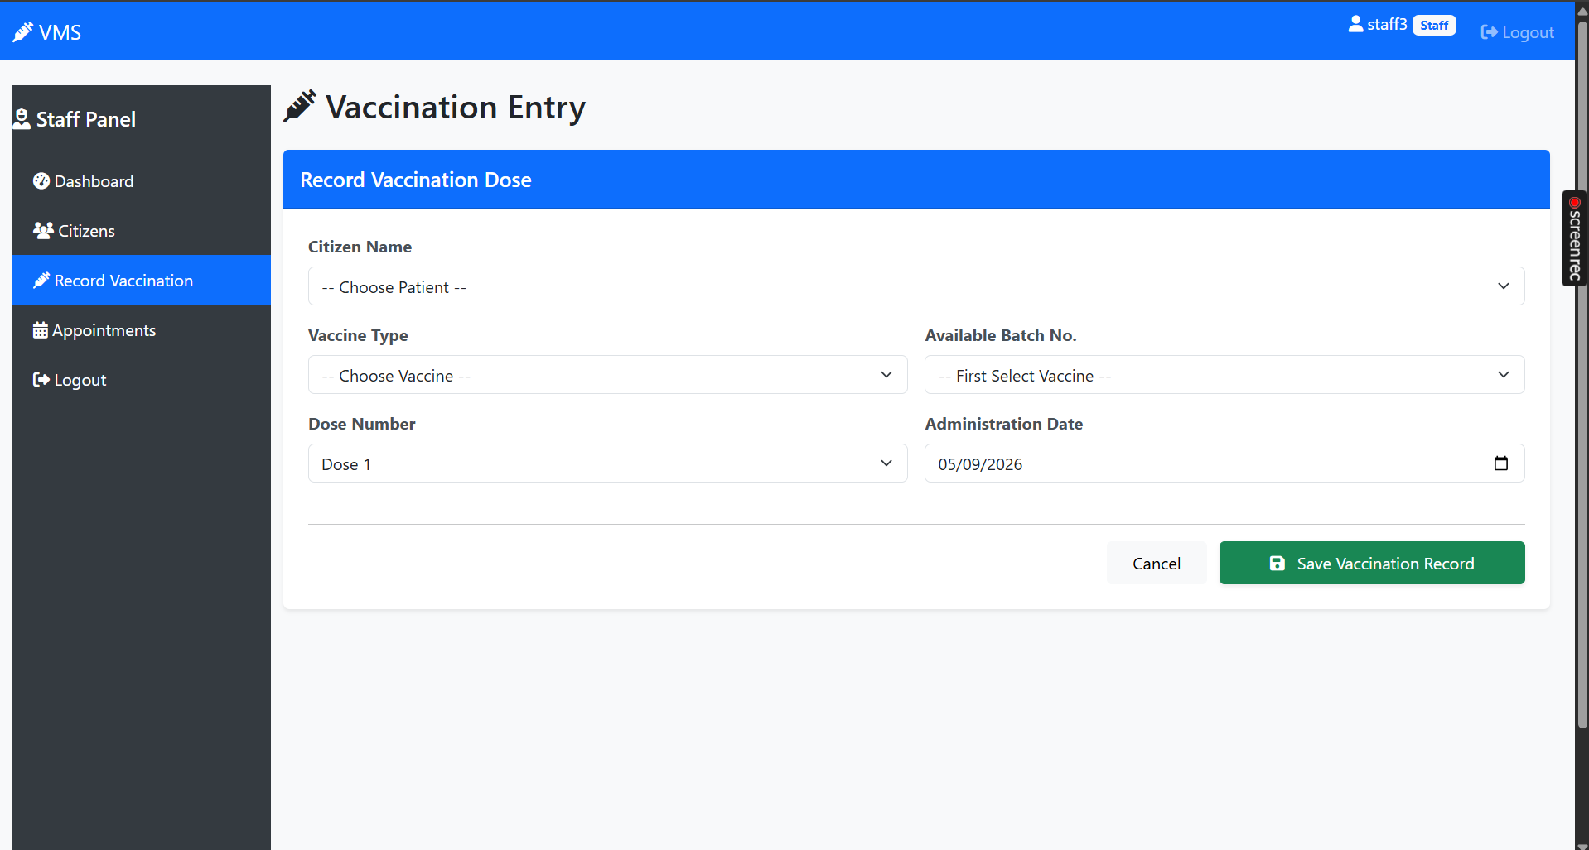

- Appointment management by staff
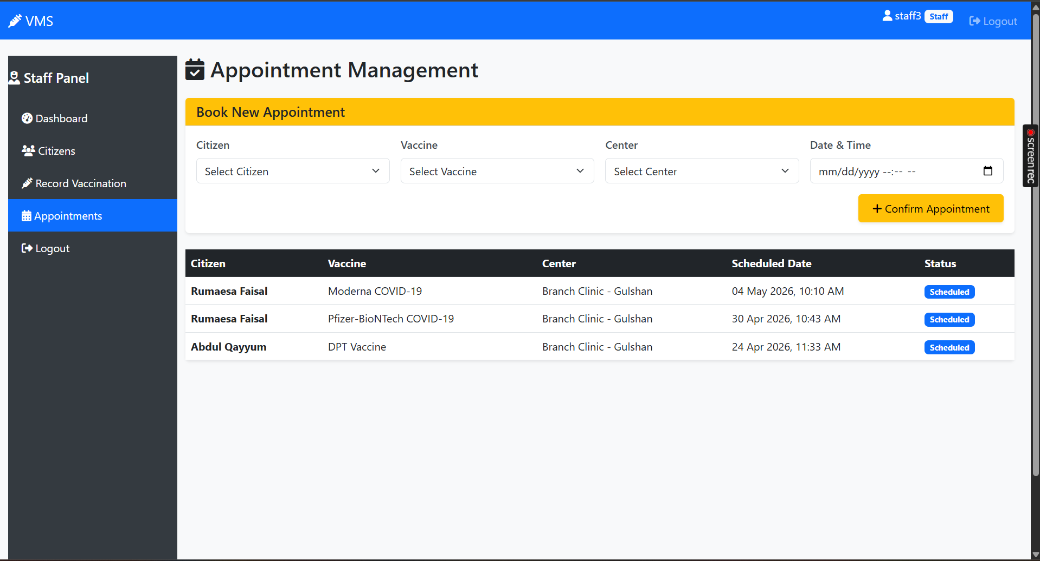

- Citizen Dashboard
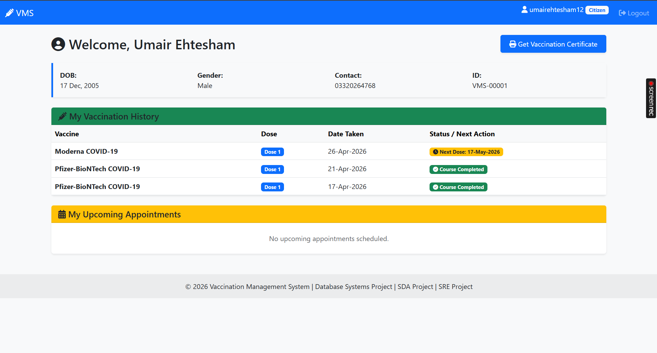

- Citizen vaccination certificate
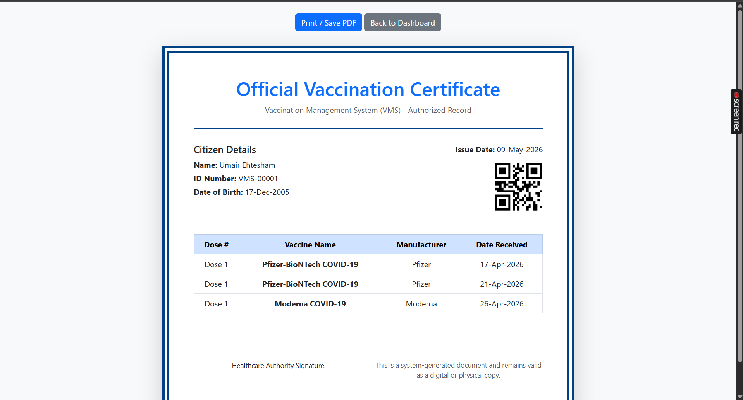

Challenges
- Exception Handling: Managing database-level errors in PHP. For instance, preventing a citizen from booking a duplicate appointment resulted in a "Fatal Error" until proper try-catch blocks were implemented.
- Stock Aggregation: Calculating total vaccine availability across multiple batches (some active and some expired) required complex SQL JOIN and GROUP BY operations.
Future Work
- Citizen Self-Service Portal: Allowing citizens to book their own appointments online.
- Automated Reminders: Integrating a WhatsApp or SMS API to remind citizens of their upcoming second dose.
- Multi-Center Support: Expand the system to manage multiple vaccination canters from a single admin panel, allowing for stock transfers between canters.

